Data Analytics with Power BI

**“360-degree business analysis of online delivery apps”**

|  |  |
| --- | --- |
| **NM ID** | **NAME** |
| 07531979A0EE92493A04F00AD548485D | RAJALAKSHMI.K |

**“ SRI PARAMAKALYANI COLLEGE ”**

TRAINER NAME: M.UMA MAHESHWARI

MASTER NAME: M.UMA MAHESHWARI

|  |
| --- |
|  |
|  |
|  |

**ABSTRACT**

The scientific advancement in urbanised locations with the relation of the lower classes and discovery to Secularized culture is boosting the growth of food delivery applications and restaurant industries in India. The convenience of users is the primary objective aspect of such, while the second thing that these software’s are also beneficial for the development of the market in eating and food supply, as the use of the online platform is a place where the restaurant owner is prepared to attract as many users as he can by allowing them to see the entire food menu in accordance with item name, price, photo, etc. Apps for food delivery have proven to be a big success in India as people are very well about all its operations and services. As one can order food for any type of occasion, it is one of the most comfortable and trusted options available. This helps to save time, resources, fuel and efforts for people, which is one of the key reasons why this industry is thriving and will tend to do so. Therefore, part of my initiative would be to review the theoretical background in various aspects of food sector apps, business models and various factors affecting adoption of food delivery apps that have never been addressed before.

**INDEX**

|  |  |
| --- | --- |
| **S.No.** | **Table of Contents** |
| 1 | Chapter 1:  Introduction |
| 2 | Chapter 2:  Procedure and Management |
| 3 | Chapter 3:  Project Architecture |
| 4 | Chapter 4:  Modeling and Result |
| 5 | Conclusion |
| 6 | Future Scope |
| 7 | References |
| 8 | Links |

**CHAPTER 1**

**INTRODUCTION**

**1.1 Problem statements**

Different food delivery applications often provide different offers or discounts. Users are also not satisfied with their delivery time and random cancellations.

Quality: In comparison to eating out in a restaurant, the food from the delivery service is packed in plastic bags and may get cold if the distance of your restaurant is far from your delivery address.

**1.2 Proposed Solution**

One of the challenges that many restaurants face is managing food orders manually. Manual food order management can lead to errors, delays, and customer dissatisfaction. Food is a solution that can automate and streamline the process of food order management. Use technology: Technology can help businesses to streamline their delivery operations and improve efficiency. For example, using route planning software, real-time tracking systems, and automated dispatching tools can all help to reduce delivery times, improve accuracy, and increase customer satisfaction.

* 1. **Feature**

Customers prefer using the food ordering app as they will generate an order without having to elucidate it to a special person and have the food is delivered at his doorstep. Moreover, online payment makes this process easier and faster.

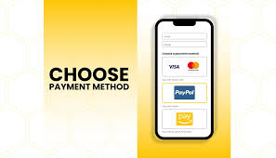Easy payment options

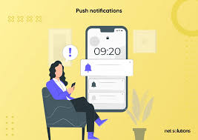 Push notifications

 Ratings and reviews

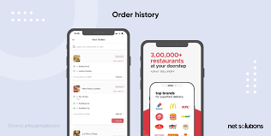 Order history

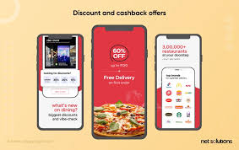 Loyalty programs

 Customer feedback

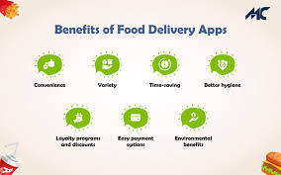 Discounts and promotions

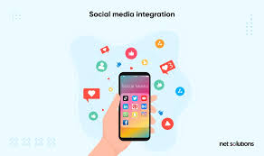 Social media integration

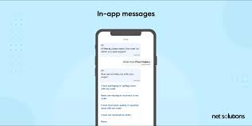 Messaging within the app

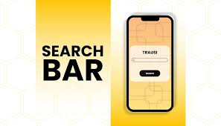 Search filters

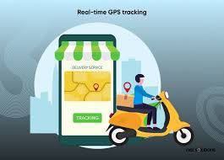 Tracking

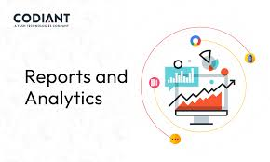 Data analysis

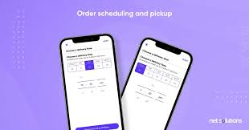 Schedule orders

* 1. **Advantages**

Better reach, management, Better customers idea, Great discounts, heightened brand awareness, commerce, Conclusion, analytics, highly customizable, multiple payment options, locality programmes.

* 1. **Disadvantages**

Deliverymen put themselves in danger, Food quality compromised, Disguised increased expense, Food may get cold, Delay, Juggling with your health

* 1. **Scope**

Online food ordering has become a popular trend among consumers, and understanding its appeal is crucial. The primary reason consumers prefer this method is convenience. With just a few clicks, you can order your favorite meal from your preferred restaurant and have it delivered to your doorstep.

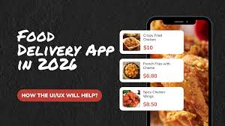

We expect the food delivery app industry to grow significantly over the next five years. According to a recent report, the global food delivery market is projected to reach 365 billion by 2026, growing at a period from 2020 to 2026.

**CHAPTER 2**

**PROCEDURE AND SOFTWARE MANAGEMENT**

**2.1 PROCEDURE**

1. Conduct a market research.
2. Choose the business model.
3. Choose a software development partner.
4. Decide on the app features.
5. Choose the tech stack.
6. Design and development
7. Testing the app
8. Launch and marketing

**2.2 SOFTWARE MANAGEMENT:**

Delivery management software is mainly used to plan and schedule orders for delivery. You can also use DMS to map and optimize routes for deliveries and service calls. And many professionals use delivery management apps to dispatch and track drivers.

Using the dispatcher panel of the food delivery software, your dispatchers can register and manage food orders. It is possible to send orders automatically and manually for drivers.

**Mobile**: This is a mobile application that you can use mobile phone to order your products.

**CHAPTER 3**

**PROJECT ARCHITECTURE**

**3.1 ARCHITECTURE**

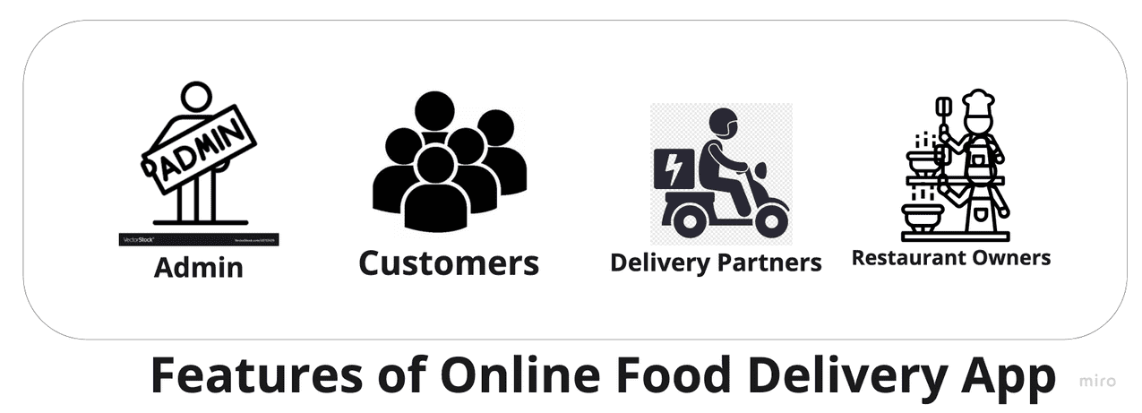For example , let us take a food delivery app and their orders .

The above diagram depicts the actual requirements for an Online Food Delivery system. It comprises of:

**Admin Panel:** Responsible for onboarding of Restaurants Owners and Delivery Partners.

**Restaurant Owners:** Responsible for adding menus and managing orders and payments.

**Delivery Partners:** Responsible for picking an order from the Restaurant Owners and delivering them to the customers.

**Customers:** They are the actual client. They will be consuming the application. The customer will make an orderfrom the system.

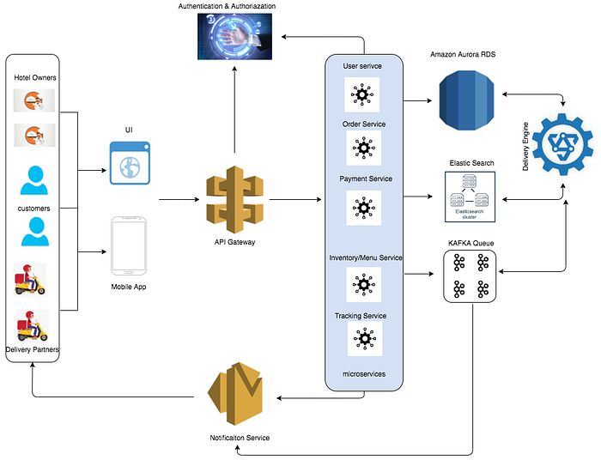

**POSSIBLE TECH STACK:**

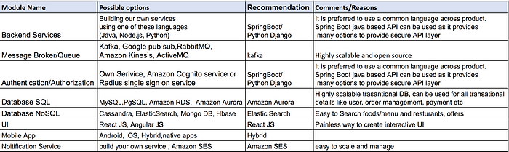

**CHAPTER 4**

**MODELING AND RESULT**

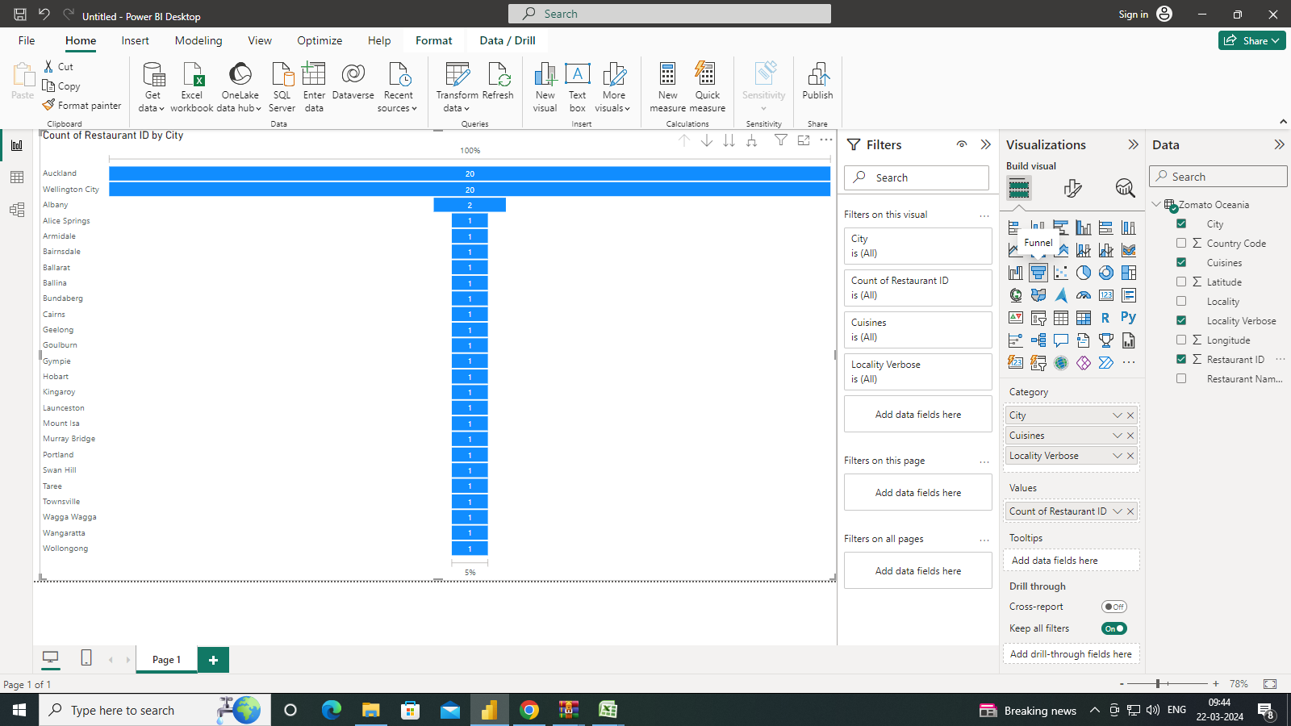

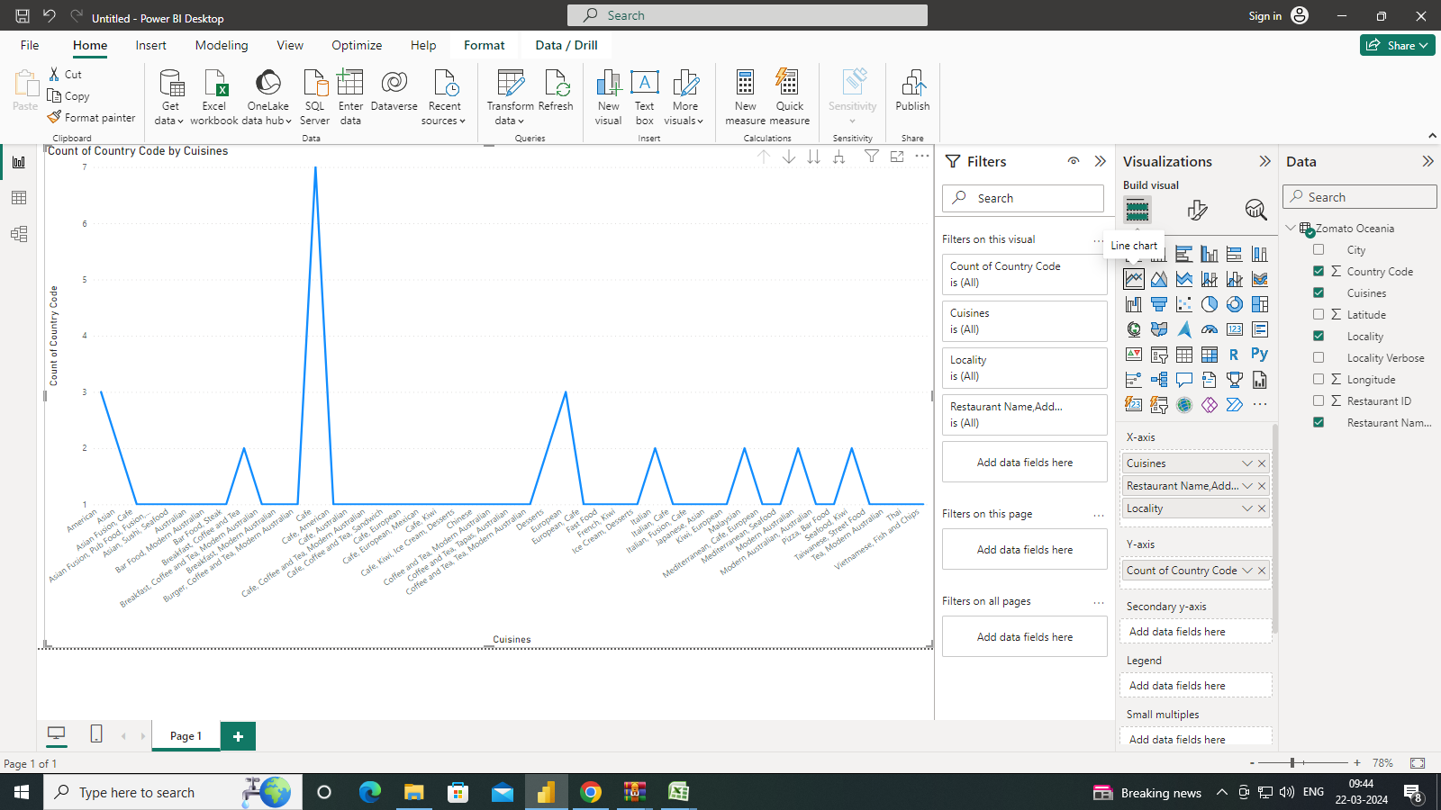

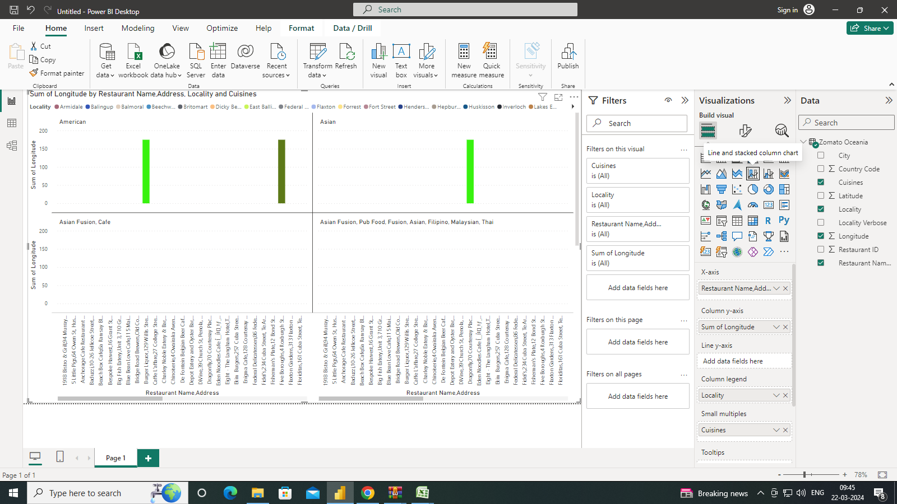

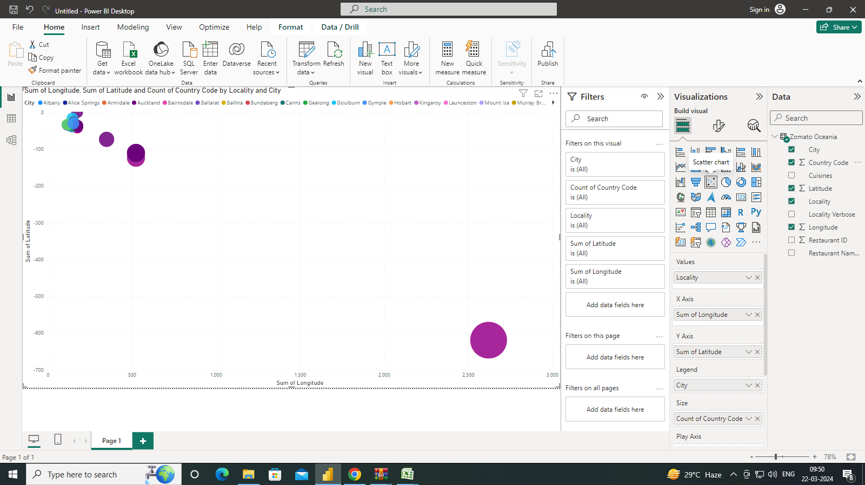

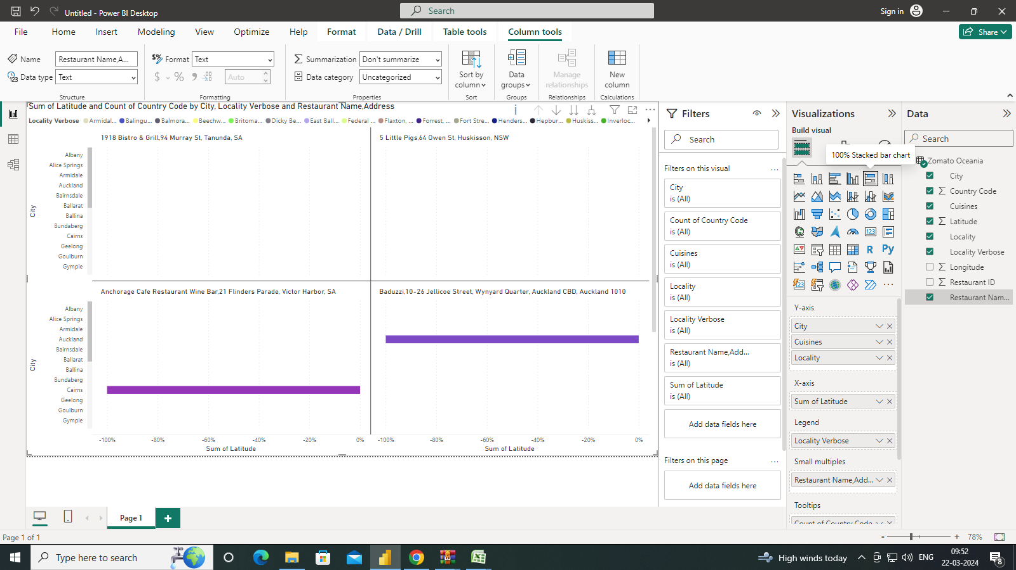

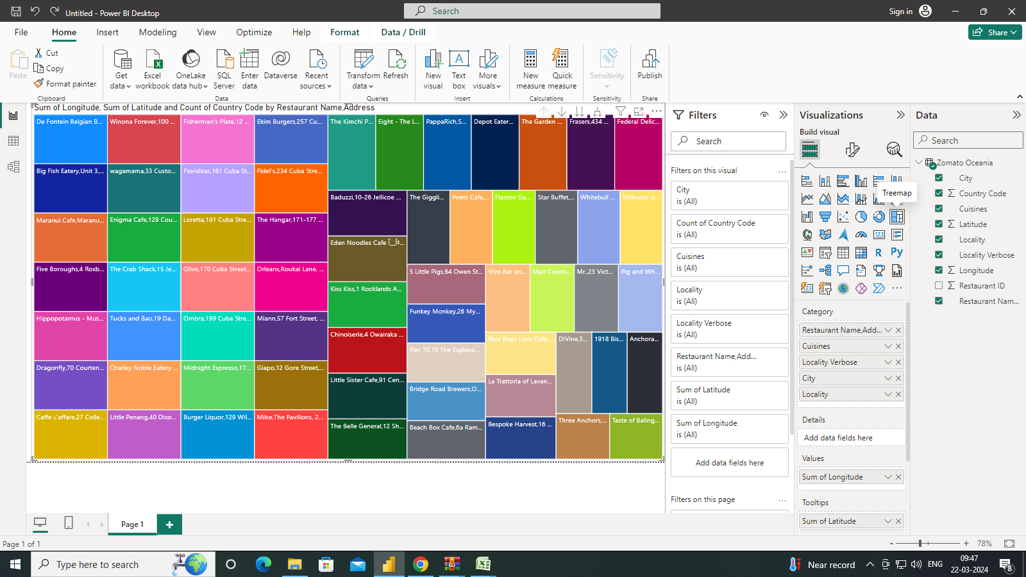

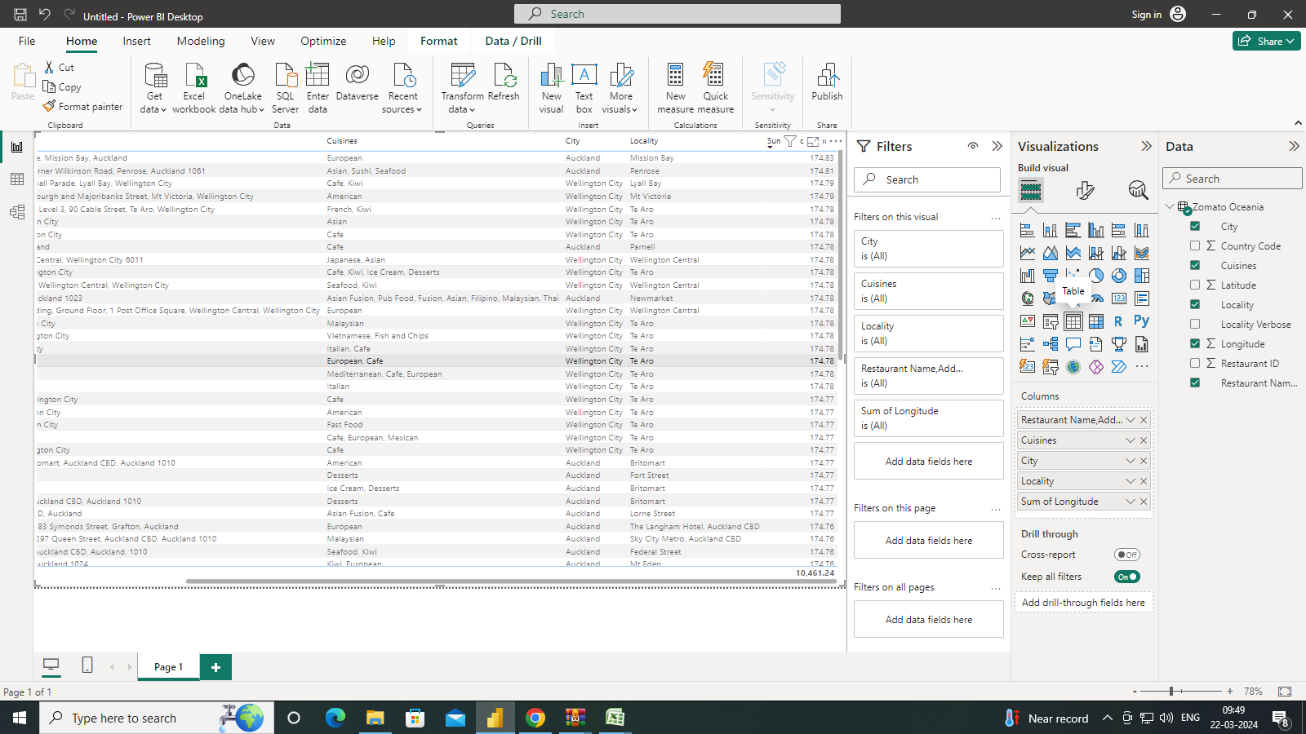

The online delivery market is evolving and expanding at a drastic scale. The unprecedented growth of the food delivery industry extends a plethora of opportunities for businesses to start an online food delivery marketplace.

 The delivery market is expected to grow 10% a year to be worth $25bn in Europe by 2023. Technological advancements have turbocharged the adoption of online food delivery services among customers and this has been the major reason for several entrepreneurs to flee towards the online food delivery market.

Strategizing the business model is one of the initial requirements for starting a new business. It is highly advisable for businesses to analyse the market, define the target audience, set business goals, and accordingly choose the business model for their online food delivery business.

Entrepreneurs should be familiar with various online food delivery business models existing in the market to make a well-informed decision. In this blog, we will discuss different business models for online food delivery business and guide you to choose the right one for your venture.

**CONCLUSION**

As we can see, online shopping may or may not be greener than traditional shopping. There are simply way too many factors that we have to consider in such a model. As we focus on the costs of online shopping, it seems that online shopping is really detrimental for the environment. Online shopping brings us great convenience, but it also encourages irresponsible consumption habits like exploiting the advantages of free returns and expedited shipping. These add on to the existing pool of environmental problems that we are dealing with – global warming, wastes and pollution. Therefore, we should change our attitude towards e-commerce – to be more responsible, less exploitative and more thoughtful for the environment.

**Consume responsibly before we are left with nothing.**

**FUTURE SCOPE**

Online delivery refers to the process of ordering and receiving food or products through digital platforms such as mobile apps or websites. Customers can place their orders through these platforms, and the restaurants or sellers deliver the requested items to the customers' specified locations. Online delivery offers several advantages, including convenience, a wide range of options, and the ability to order from anywhere. However, there are also challenges associated with online delivery, such as issues with order accuracy, delivery delays, and payment security.

The COVID-19 pandemic has further highlighted the importance of online delivery as it allows people to access food and essential items while minimizing physical contact. Various studies have been conducted to improve the efficiency and safety of online delivery, including the development of hierarchical delivery frameworks and algorithms to optimize delivery routes.

**REFERENCES**

<https://typeset.io/questions/what-is-online-delivery-2tynasssnd>

<https://sandesh-deshmane.medium.com>